Task 3
Treatment Type Selection by Cancer Stage

- How do treatment choices (surgery, chemotherapy, radiation, combined) differ across cancer stages?
- Plot treatment type frequencies grouped by cancer stage.

Output

- Terminal
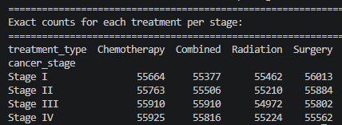
- Graph Output
